Academic Performance and Student Support in Colombian Engineering Education
Case Study Report Assignment 1
Christina Fan
University of Pennsylvania
Course 6070
Submission date: 9/30/2026

Executive Summary
This report analyzes 12,411 Colombian engineering education records. The mean global assessment score is 162.71. Selected parental-education gaps are 18.20 points for fathers and 17.17 for mothers; the Stratum 6–Stratum 1 gap is 29.16 points. The global gender gap is 2.41 points, with contrasting quantitative-reasoning and writing patterns. Earlier subject scores correlate positively with later performance (r = 0.635–0.667). The findings support a diagnostic support pilot with outreach to students facing resource barriers. These descriptive associations do not establish causation or intervention benefits.

1 Introduction
The Department of Education needs evidence to identify learning needs and unequal educational opportunities. This report examines how parental education, socioeconomic stratum, gender, and academic program relate to the recorded global assessment score (G_SC), and which secondary-school subjects are most strongly associated with later performance.
The dataset links final-year secondary-school and professional-stage engineering assessments for 12,411 records from Colombia, with background information on parental education, stratum, gender, and SISBEN. It is available through Mendeley Data (De La Hoz). STRATUM is the recorded socioeconomic classification. The analysis informs support priorities without treating background characteristics as fixed limits on individual potential.

2 Analytical Goals and Decision Criteria
G_SC is the primary outcome; domain scores provide additional context. Fathers’ and mothers’ education are analyzed separately, and stratum is kept distinct from SISBEN. Support options are judged by observed differences, group sizes, delivery feasibility, and equitable access. Individual learning needs guide eligibility, while background patterns inform outreach. The data contain no intervention costs or effects, so financial returns cannot be estimated.

3 Data Preparation and Analytical Approach
Google Colab, pandas, Matplotlib, and Seaborn were used for preparation, summaries, and visualization. Removing the entirely empty Unnamed: 9 column left 12,411 rows and 44 columns, with no blank entries in the remaining original columns. Spaces were trimmed in six grouping variables; undocumented zero codes became Unspecified (391 father-education, 388 mother-education, 14 stratum, and 21 SISBEN records). Not sure and Ninguno remained distinct, and numerical scores and potential outliers were retained.
No complete-row duplicates or repeated secondary-school identifiers were found. Sixteen repeated professional-test identifiers involved 32 rows with different secondary-school identifiers; these were retained because the linkage could not be resolved. The sample is therefore described as records, rather than verified independent individuals.
Descriptive summaries, group comparisons, distributions, and Pearson correlations follow the course material ("Descriptive Statistics"). Results correspond to saved notebook outputs; differences use unrounded means. Gender, stratum, and both parental-education summaries each total 12,411 records and reproduce the weighted mean of 162.710499. No significance tests or adjusted regression models were fitted. Cross-stage score differences are not learning gains, and raw scores across domains need not be comparable. The sample is not assumed to be random or representative of all students. Appendices A–C provide detailed summaries and reproducibility information; Appendices D and E contain all tables and figures previously shown in the analysis.

4 Data Analysis
Across 12,411 records, the global assessment score has a mean of 162.71, a median of 163.00, and a standard deviation of 23.11. These values provide context for interpreting the following comparisons. All differences and correlations are descriptive associations.

4.1 Parental Education and Academic Outcomes
Higher parental education is associated with higher average global assessment scores, although the pattern is not strictly increasing across every category. For fathers, the postgraduate group has a mean of 176.99, compared with 158.79 for the completed-secondary group. The mean difference is 18.20 points. The corresponding medians are 179.00 and 159.00, indicating that the contrast is also evident in the center of the distributions rather than only in their means. The completed-professional-education group has an intermediate mean of 167.77.
A similar pattern appears for mothers. The postgraduate group has a mean of 175.64, compared with 158.47 for the completed-secondary group, a difference of 17.17 points. Their medians are 178.00 and 159.00, respectively. The mean for completed professional education is 168.85. Table 1 in Appendix D places these selected comparisons side by side; Figures 1 and 2 in Appendix E show the complete set of parental-education category means.
The parental contrasts are substantial in raw score terms relative to the small gender contrast discussed below, but they do not identify an independent contribution from either parent. Fathers’ and mothers’ education may be related to one another, socioeconomic circumstances, or earlier educational opportunities. The slightly larger paternal contrast cannot establish that fathers have a stronger influence than mothers because the two comparisons involve different group memberships and no statistical controls.
The full category patterns also qualify the association. For example, the paternal incomplete-primary mean is 155.73, slightly above the complete-primary mean of 155.20. Unspecified and Not sure are not education levels, while small categories require caution: the maternal Ninguno group contains only 34 records. Parental education is associated with outcomes, with postgraduate-versus-completed-secondary differences of 18.20 points for fathers and 17.17 points for mothers. These are unadjusted descriptive differences, not estimates of the score gains caused by changing parental education.

4.2 Performance across Strata and Academic Programs
Stratum 6 has the highest mean global score, 181.51, while Stratum 1 has the lowest, 152.35. Their mean difference, calculated in the notebook before rounding, is 29.16 points. More generally, both means and medians increase across the six specified strata. This consistent ordering provides stronger descriptive evidence of a socioeconomic gradient than a comparison of the two extreme groups alone.
The groups differ considerably in size: Stratum 1 contains 1,709 records, compared with 403 in Stratum 6. Standard deviations across the six strata range from 21.47 to 22.28, showing appreciable variation within every group. Figure 3 in Appendix E confirms that higher strata tend to have higher score distributions, while the distributions still overlap. Consequently, stratum is relevant to understanding differences in average performance but does not determine an individual student’s result.
Academic-program comparisons provide additional context for the assignment’s interest in students in different programs. Chemical engineering has the highest observed program mean, 176.70, based on 1,000 records, with a median of 177.00 and a standard deviation of 18.69. Catastral engineering and geodesy follows with a mean of 174.60 based on 78 records. The two largest programs, industrial engineering and civil engineering, have means of 159.04 and 161.11, respectively. Table 3 in Appendix D selects the leading programs and the two largest programs to make both performance and service scale visible.
These program averages should not be interpreted as rankings of teaching effectiveness. Differences may reflect prior preparation, student selection, or institutional context, none of which is controlled here. The lowest-ranked category, industrial control and automation engineering, contains only one record with a score of 113.00; textile engineering also contains one record. Such categories cannot support stable conclusions about a program population. Stratum 6 and chemical engineering lead their respective observed mean comparisons, while group size, score overlap, and unmeasured differences limit the conclusions that can be drawn.

4.3 Gender Differences in the Global Assessment
Male records have a mean global score of 163.69, compared with 161.28 for female records. The male-minus-female mean difference is 2.41 points. Their medians are 164.00 and 162.00, respectively. The comparison includes 7,368 male records and 5,043 female records, corresponding to 59.37% and 40.63% of the dataset.
The 2.41-point gap is small relative to the within-group standard deviations of 23.58 for males and 22.33 for females. The boxplots in Figure 4 in Appendix E also show considerable overlap. The global comparison therefore supports a slight male advantage in the observed average, not a general claim that male students outperform female students across all abilities or that gender determines individual achievement. No statistical significance claim is made.
Domain-level results reveal an important distinction concealed by the global score. Male records have a higher mean in quantitative reasoning, 81.20 compared with 71.89. Female records have a higher mean in written communication, 56.62 compared with 51.71. Male means are also higher in critical reading, citizenship competencies, and English, while the project-formulation means are close, at 145.6 and 145.3. Table 5 in Appendix D demonstrates that the direction and size of the gender contrast depend on the assessed domain.
Males have a slightly higher observed global mean, but the domain results do not show a uniform male advantage. For educational planning, this distinction supports using individual diagnostic results in quantitative reasoning and writing rather than treating the global gender average as a sufficient guide to support needs.

4.4 Interpretation and Educational Implications
Three findings are particularly relevant to the Department of Education. First, the stratum contrast and selected parental-education contrasts are larger in raw global-score points than the gender contrast. This suggests that family and socioeconomic context deserve attention when investigating unequal learning opportunities. These comparisons are descriptive contrasts between selected groups, however, and cannot rank the causal importance of the background variables. Second, the opposite gender patterns in quantitative reasoning and written communication show why a single global score can obscure distinct learning needs. Third, earlier academic achievement is consistently associated with later global performance.
Together, these findings distinguish outreach priorities from eligibility for support. The socioeconomic and parental-education patterns justify investigating resource barriers, while overlapping distributions and contrasting domain results argue for assessing each student’s needs. Group averages can help identify questions for educational planning, but they do not provide a sufficient basis for assigning individual ability or judging program effectiveness. Sections 5 and 6 use these distinctions to compare support options and propose an evaluation approach.

4.5 Prior Academic Achievement and Later Performance
The supplementary question is which secondary-school subject scores are most strongly associated with global performance near the end of an engineering degree. Table 6 in Appendix D reports the five correlations, and Figure 5 in Appendix E places them alongside the relationships among the earlier subject scores.
All five secondary-school measures have positive correlations with G_SC, ranging from 0.635 to 0.667. Biology has the largest observed coefficient, 0.667, followed by English at 0.662. The coefficients are closely spaced, and no test comparing their magnitudes was performed. The pattern suggests that the association with later performance extends across several areas of prior preparation rather than being confined to mathematics.
The earlier subject scores are also correlated with one another, so the separate correlations cannot identify each subject’s independent contribution. Biology’s numerical lead does not show that increasing biology instruction would improve global scores. Figure 6 in Appendix E illustrates the mathematics association, with a correlation of 0.644, while showing variation in global outcomes among records with similar earlier mathematics scores. Prior results can therefore inform diagnostic assessment and bridging support without becoming fixed predictions of individual potential.

5 Preferred Alternative with Rationale
The preferred option combines individual diagnostic assessment with proactive outreach to students facing resource barriers. A uniform tutoring curriculum may waste limited teaching time, while support allocated solely by gender or stratum overlooks individual variation. Quantitative-reasoning support, writing workshops, and broader bridging assistance should respond to demonstrated needs. A small pilot using existing advising and tutoring capacity where available would test staffing, accessibility, scheduling, demand, and costs before expansion. These are proposals, not established cost advantages; program means do not justify punitive funding decisions.

6 Recommendations and Predicted Outcomes
Pilot diagnostics using prior academic information and current quantitative-reasoning and writing assessments. Offer accessible support across backgrounds, with additional outreach where resource barriers may reduce participation. Plan staffing against verified current demand: industrial and civil engineering account for 5,318 and 3,320 historical records, respectively, but these counts are not enrollment forecasts.
Track invitations, participation, completion, staff time, costs, and learning on comparable measures. Use a credible comparison group or phased rollout where practicable. Intended outcomes are better identification of unmet needs, wider access to appropriate assistance, and improved domain performance. These remain hypotheses; expansion should depend on observed outcomes, participation, feasibility, and costs. The dataset cannot predict numerical gains or causal program benefits.

7 Conclusion
Socioeconomic and selected parental-education gaps exceed the global gender gap, while gender patterns vary by domain. Chemical engineering has the highest observed program mean, and prior achievement is positively associated with later performance. These findings favor an evaluated support pilot based on individual needs and resource barriers. Unmeasured differences and data limitations preclude causal conclusions.

References
De La Hoz, Enrique. “Data of Academic Performance evolution for Engineering Students.” Mendeley Data, version 1, 10 Feb. 2020, https://doi.org/10.17632/83tcx8psxv.1. Dataset.
“Descriptive Statistics and Visualization Summary.” Course 6070 instructional handout, University of Pennsylvania, n.d. PDF.
Fan, Christina. Assignment_1_Simplified.ipynb. Course 6070, University of Pennsylvania, n.d. Unpublished Google Colab analysis notebook.

Appendix A Full Parental Education Summaries
The following tables retain the original category labels. Display precision is standardized without changing numerical values. Unspecified and Not sure are not educational attainment levels.
Table A1
Global Scores by Father’s Education
Education category | Count | Mean | Median | SD
Complete Secundary | 2,843 | 158.79 | 159.00 | 22.11
Complete primary | 824 | 155.20 | 155.00 | 22.41
Complete professional education | 3,016 | 167.77 | 169.00 | 23.03
Complete technique or technology | 1,194 | 164.03 | 164.00 | 22.17
Incomplete Professional Education | 425 | 166.92 | 168.00 | 22.69
Incomplete Secundary | 1,091 | 156.54 | 157.00 | 21.74
Incomplete primary | 735 | 155.73 | 156.00 | 20.94
Incomplete technical or technological | 277 | 162.10 | 162.00 | 21.88
Ninguno | 123 | 156.63 | 159.00 | 23.19
Not sure | 407 | 160.29 | 159.00 | 22.94
Postgraduate education | 1,085 | 176.99 | 179.00 | 21.73
Unspecified | 391 | 155.08 | 155.00 | 20.06
Source: Author’s calculations using the assignment dataset (De La Hoz), Colab Steps 11–12.

Table A2
Global Scores by Mother’s Education
Education category | Count | Mean | Median | SD
Complete Secundary | 3,106 | 158.47 | 159.00 | 21.95
Complete primary | 713 | 155.34 | 155.00 | 22.01
Complete professional education | 3,059 | 168.85 | 170.00 | 22.98
Complete technique or technology | 1,495 | 163.24 | 163.00 | 21.94
Incomplete Professional Education | 502 | 166.69 | 168.00 | 22.93
Incomplete Secundary | 1,056 | 155.67 | 156.00 | 21.93
Incomplete primary | 541 | 154.85 | 155.00 | 21.64
Incomplete technical or technological | 341 | 161.88 | 164.00 | 20.74
Ninguno | 34 | 149.71 | 152.50 | 27.93
Not sure | 179 | 159.41 | 159.00 | 25.47
Postgraduate education | 997 | 175.64 | 178.00 | 22.12
Unspecified | 388 | 154.93 | 155.00 | 19.95
Source: Author’s calculations using the assignment dataset (De La Hoz), Colab Steps 11–12.

Appendix B Full Academic Program Comparison
Table B1
Global Scores by Academic Program
Academic program | Count | Mean | Median | SD
Chemical Engineering | 1,000 | 176.70 | 177.00 | 18.69
Catastral Engineering And Geodesy | 78 | 174.60 | 176.00 | 14.95
Electric Engineering | 278 | 173.99 | 174.50 | 19.35
Production Engineering | 60 | 172.90 | 176.50 | 20.56
Topographic Engineery | 42 | 172.71 | 174.00 | 15.76
Control Engineering | 20 | 172.15 | 170.00 | 20.91
Textile Engineering | 1 | 171.00 | 171.00 | —
Transportation And Road Engineering | 27 | 167.74 | 170.00 | 10.46
Electronic Engineering | 849 | 166.87 | 167.00 | 22.20
Industrial Automatic Engineering | 22 | 166.09 | 162.50 | 14.41
Mechanical Engineering | 1,135 | 166.05 | 166.00 | 23.26
Automation Engineering | 10 | 165.50 | 162.00 | 22.07
Productivity And Quality Engineering | 29 | 162.10 | 163.00 | 17.64
Civil Engineering | 3,320 | 161.11 | 161.00 | 22.83
Electric Engineering And Telecommunications | 47 | 160.43 | 160.00 | 22.15
Industrial Engineering | 5,318 | 159.04 | 159.00 | 23.16
Aeronautical Engineering | 44 | 155.80 | 158.00 | 18.80
Civil Constructions | 14 | 151.86 | 150.50 | 9.94
Mechatronics Engineering | 82 | 151.56 | 151.50 | 22.00
Electromechanical Engineering | 34 | 148.62 | 156.00 | 23.48
Industrial Control And Automation Engineering | 1 | 113.00 | 113.00 | —
Source: Author’s calculations using the assignment dataset (De La Hoz), Colab Step 19. A dash indicates that sample SD cannot be calculated from one observation; it does not mean zero variation in a program population.

Appendix C Variables and Reproducibility
Table C1
Principal Assessment Variables
Variable | Meaning
G_SC | Recorded global assessment score
MAT_S11 | Secondary-school mathematics
CR_S11 | Secondary-school critical reading
CC_S11 | Secondary-school citizenship competencies
BIO_S11 | Secondary-school biology
ENG_S11 | Secondary-school English
QR_PRO | Professional-stage quantitative reasoning
CR_PRO | Professional-stage critical reading
CC_PRO | Professional-stage citizenship competencies
ENG_PRO | Professional-stage English
WC_PRO | Professional-stage written communication
FEP_PRO | Professional-stage engineering project formulation
Source: Assignment workbook definitions and the accompanying analysis notebook.
The executed notebook provides the reproducibility record (Fan). The working sample contains 12,411 rows and 44 columns. Gender, stratum, and both parental-education summaries each total 12,411 records and reproduce the weighted mean of 162.710499. Sixteen repeated professional-test identifiers involve 32 retained rows.
Tables reproduce saved notebook outputs; Figures 1–6 in Appendix E are the original saved images. Mean differences were calculated before rounding, explaining any discrepancy from subtraction of displayed means.

Appendix D Analysis Tables
Tables 1–6 support the comparisons discussed in Section 4. Their original numbering is retained.
Table 1
Selected Parental Education Comparisons
Parent | Education category | Count | Mean | Median | SD
Father | Completed secondary | 2,843 | 158.79 | 159.00 | 22.11
Father | Completed professional education | 3,016 | 167.77 | 169.00 | 23.03
Father | Postgraduate education | 1,085 | 176.99 | 179.00 | 21.73
Mother | Completed secondary | 3,106 | 158.47 | 159.00 | 21.95
Mother | Completed professional education | 3,059 | 168.85 | 170.00 | 22.98
Mother | Postgraduate education | 997 | 175.64 | 178.00 | 22.12
Source: Author’s calculations using the assignment dataset (De La Hoz), Colab Steps 11–12. SD = sample standard deviation. Selected education labels have been shortened for readability. Mean differences use unrounded means; Appendix A retains the full original categories.

Table 2
Global Assessment Scores by Stratum
Stratum | Count | Mean | Median | SD
Stratum 1 | 1,709 | 152.35 | 152.00 | 21.94
Stratum 2 | 4,029 | 158.20 | 158.00 | 22.28
Stratum 3 | 4,045 | 163.82 | 164.00 | 21.69
Stratum 4 | 1,578 | 172.00 | 174.00 | 21.47
Stratum 5 | 633 | 177.39 | 179.00 | 21.54
Stratum 6 | 403 | 181.51 | 184.00 | 21.88
Unspecified | 14 | 154.00 | 152.50 | 21.32
Source: Author’s calculations using the assignment dataset (De La Hoz), Colab Step 14. Unspecified records remain in the sample but are not an ordered socioeconomic level.

Table 3
Selected Academic Program Comparisons
Academic program | Count | Mean | Median | SD
Chemical Engineering | 1,000 | 176.70 | 177.00 | 18.69
Catastral Engineering And Geodesy | 78 | 174.60 | 176.00 | 14.95
Electric Engineering | 278 | 173.99 | 174.50 | 19.35
Industrial Engineering | 5,318 | 159.04 | 159.00 | 23.16
Civil Engineering | 3,320 | 161.11 | 161.00 | 22.83
Source: Author’s calculations using the assignment dataset (De La Hoz), Colab Step 19. The three highest observed program means and the two largest programs are shown. Appendix B presents the complete ranking.

Table 4
Global Assessment Scores by Gender
Gender | Count | Mean | Median | SD
Female | 5,043 | 161.28 | 162.00 | 22.33
Male | 7,368 | 163.69 | 164.00 | 23.58
Source: Author’s calculations using the assignment dataset (De La Hoz), Colab Step 16.

Table 5
Professional Assessment Means by Gender
Assessment domain | Female mean | Male mean
Quantitative reasoning (QR_PRO) | 71.89 | 81.20
Critical reading (CR_PRO) | 61.34 | 62.79
Citizenship competencies (CC_PRO) | 58.57 | 59.61
English (ENG_PRO) | 66.53 | 68.16
Written communication (WC_PRO) | 56.62 | 51.71
Engineering project formulation (FEP_PRO) | 145.30 | 145.60
Source: Author’s calculations using the assignment dataset (De La Hoz), Colab Step 18. Compare genders within each domain; different domains need not share comparable score scales.

Table 6
Secondary School Scores and the Global Assessment
Secondary school assessment | Pearson correlation with G_SC
Mathematics (MAT_S11) | 0.644
Critical reading (CR_S11) | 0.654
Citizenship competencies (CC_S11) | 0.635
Biology (BIO_S11) | 0.667
English (ENG_S11) | 0.662
Source: Author’s calculations using the assignment dataset (De La Hoz), Colab Step 20. The self-correlation of G_SC with itself is omitted.

Appendix E Analysis Figures
Figures 1–6 support the distributions and associations discussed in Section 4. Their original numbering is retained.
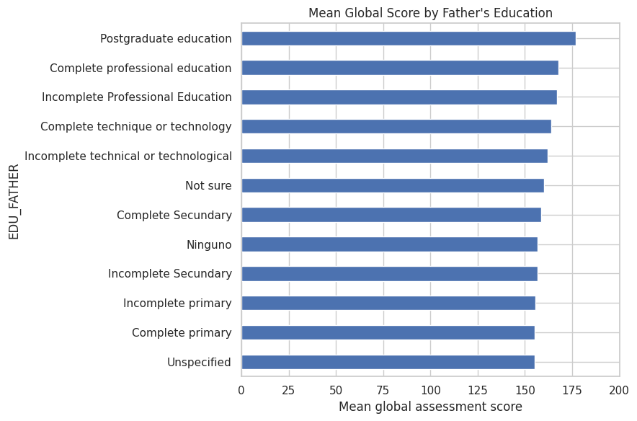
Fig. 1. Mean global assessment score by father’s education. Source: Author’s visualization using the assignment dataset (De La Hoz); saved Colab output. Categories are ordered by observed mean; bars do not show uncertainty intervals.

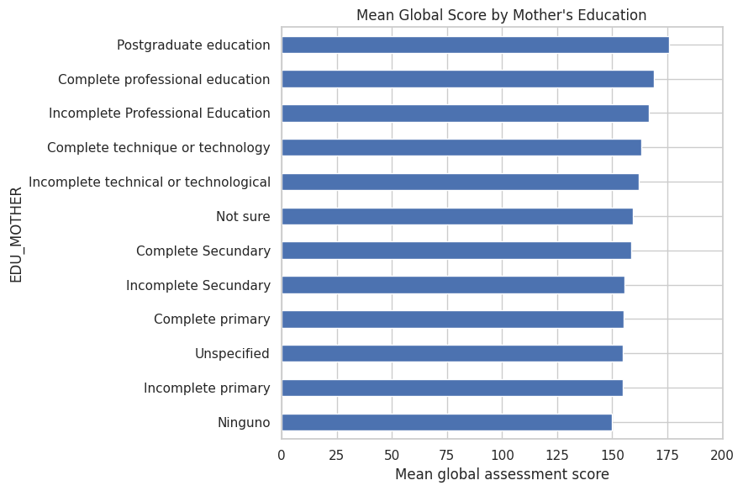
Fig. 2. Mean global assessment score by mother’s education. Source: Author’s visualization using the assignment dataset (De La Hoz); saved Colab output. Original category labels are retained.

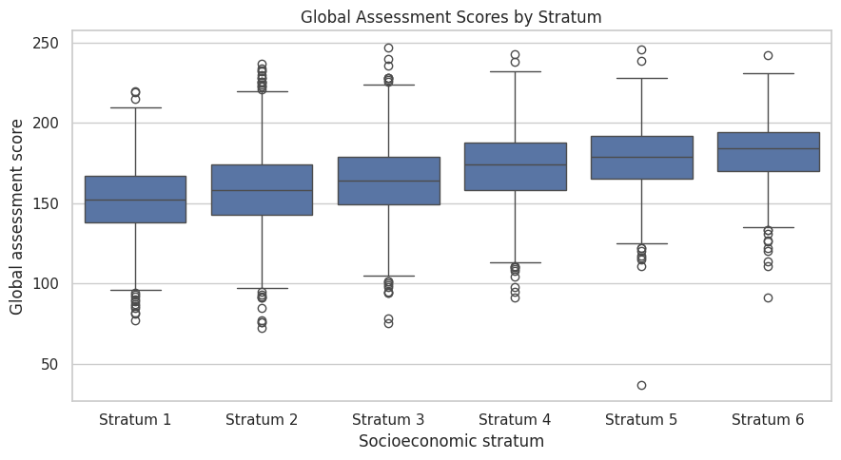
Fig. 3. Global assessment score distributions by stratum. Source: Author’s visualization using the assignment dataset (De La Hoz); saved Colab output. The 14 unspecified records are included in Table 2 but excluded from the ordered plot.

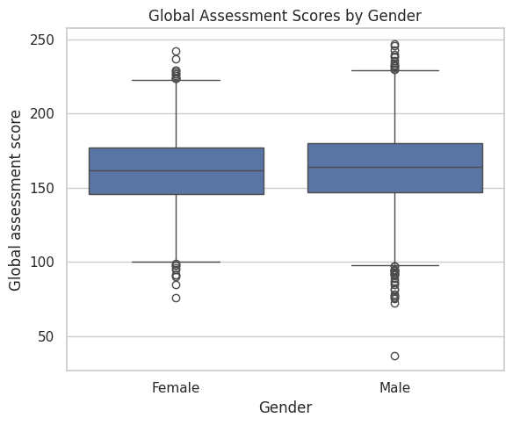
Fig. 4. Global assessment score distributions by gender. Source: Author’s visualization using the assignment dataset (De La Hoz); saved Colab output.

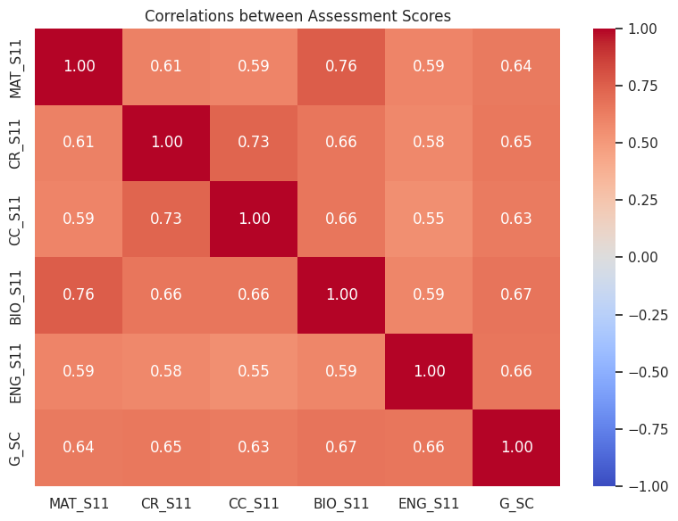
Fig. 5. Correlations among secondary-school subject scores and the global assessment score. Source: Author’s visualization using the assignment dataset (De La Hoz); saved Colab output. Figure labels use two decimals; Table 6 retains three. Diagonal values of 1.00 are self-correlations. See Appendix C for variable definitions.

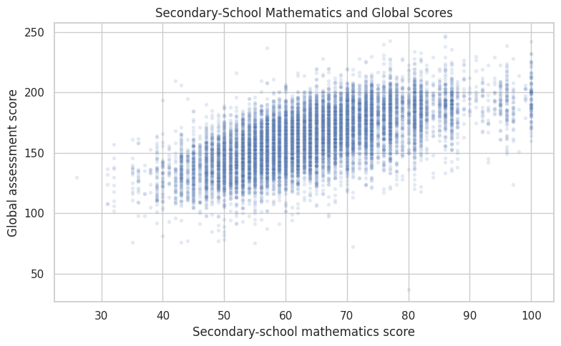
Fig. 6. Secondary-school mathematics and global assessment scores. Source: Author’s visualization using the assignment dataset (De La Hoz); saved Colab output. The scatterplot describes association; it does not estimate learning gains or an adjusted regression model.

